Saturday, August 8, 2026 from 8:00 a.m. to 4:30 p.m.

16th Annual Phoenix Community Garage Sale

Hosted by St. Stephen’s Altar Rosary Society, 469 Main Street, Phoenix, NY 13135
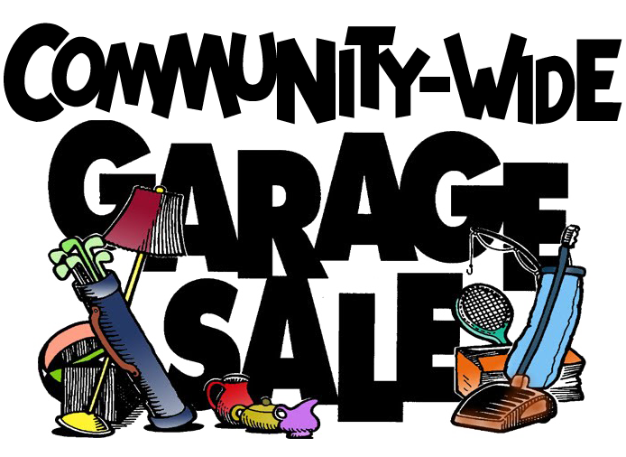

Come Join Us and Help Make This a Community Event!
Look to Advertise Your Garage Sale or Want to Rent a Table to Sell Items, at the headquarters, in the Back Parking Lot at St. Stephen’s Church?
Contact Us and See How We Can Work Together.
*Registration Deadline is August 1, 2026 @ 11:59 p.m.

*Garage Sale Numbered Signs are Due back August 8, 2026 @ 4:30 p.m.

Any Questions or Want to Make a Reservation?
Contact Emily Reilley; Cell: (315)200-3500 text or call
Email Address: ststephensaltarrosary@gmail.com
Join through Remind: https://www.remind.com/join/8thannu

Just email your name, email address, phone number, address, and request (Rent a table or List a Sale). Donations encouraged and welcomed to help cover publicity costs. We advertise by social media, flyers, news channels, garage sale directory map, and local newspapers.

Emily Reilley or Maureen Dominic
(315)200-3500 or (315)695-7017♦ Email: ststephensaltarrosary@gmail.com♦ http://www.ststephensphoenix.com/

